LAPO MICROFINANCE COMPANY (SL) ENVIRONMENTAL AND SOCIAL GOVERNANCE (ESG) ANNUAL REPORT FOR THE YEAR 2024

- The Environment

  - Tree Planting Project:
In the third quarter of 2024, LAPO Microfinance Company (SL) Ltd., through its Sustainability Unit, executed a major environmental sustainability initiative by planting a total of 1,330 trees in three districts across Sierra Leone. The goal was to contribute to environmental conservation, combat climate change, and promote biodiversity.
Achievements:
Location | Chiefdom | District | Forest Trees | Economic Trees | Total Trees
Mordia Line | Magbema | Kambia | 600 | 30 | 630
Chaindocome | Maforki | Portloko | 0 | 300 | 300
Tombay | Fakunya | Moyamba | 400 | 0 | 400
Total |  |  | 1,000 | 330 | 1,330
Impact:
- Improved local biodiversity and green cover.
- Support to local agriculture and livelihood through economic trees.
- Community engagement and awareness in environmental sustainability.

BELOW ARE SOME PICTURES CAPTURING THE ABOVE ACTIVITIES

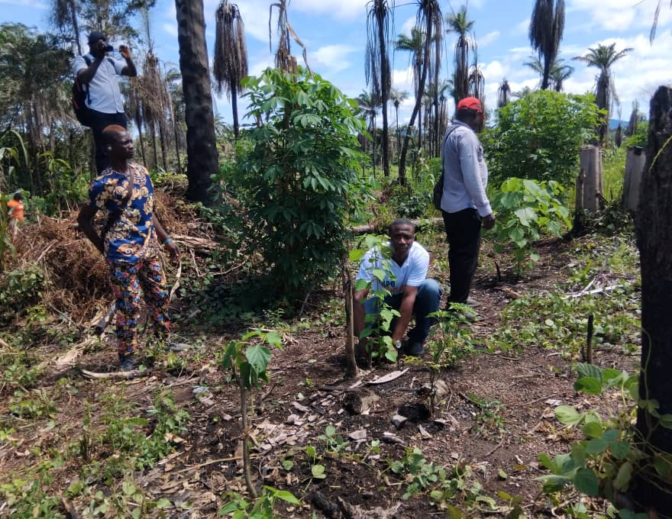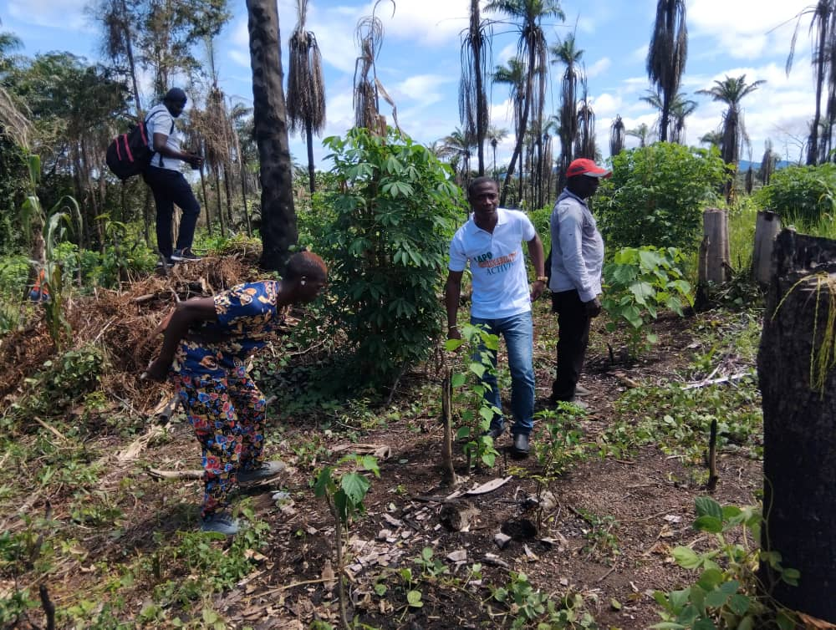
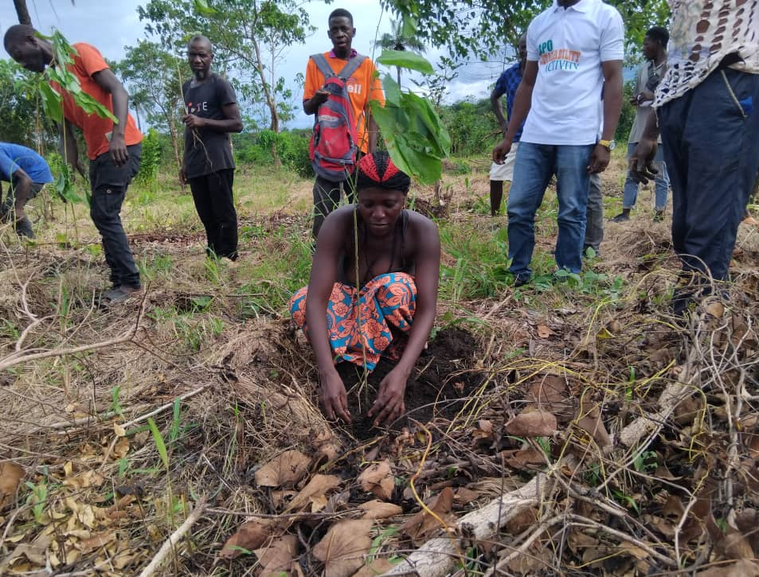
  - Cleaning of Market Place:
In December 2024, the Sustainability Unit led a cleaning exercise at Krootown Road Market. This initiative was aimed at promoting public health and hygiene in business environments.
Outcomes:
Date | Location | No. of Beneficiaries
7th December | Krootown Road Market | Hundreds of market clients
Impact:
- First institutional cleaning of the market as acknowledged by beneficiaries.
- Encouraged cleaner market practices.
- Enhanced LAPO's reputation as a socially responsible institution.

BELOW ARE SOME PICTURES CAPTURING THE ABOVE ACTIVITIES

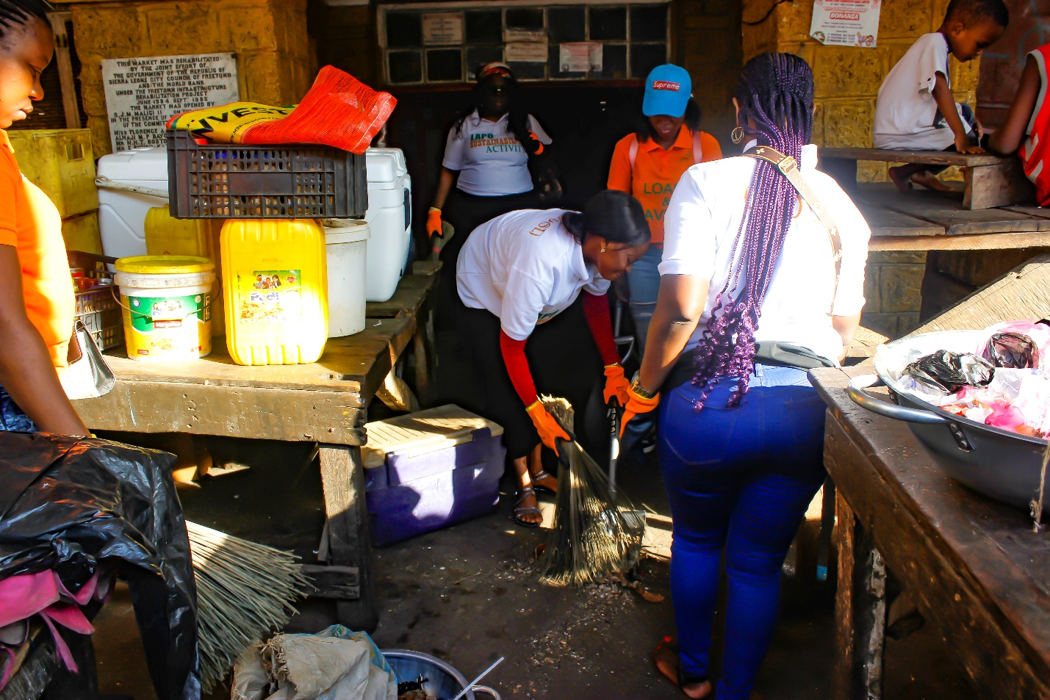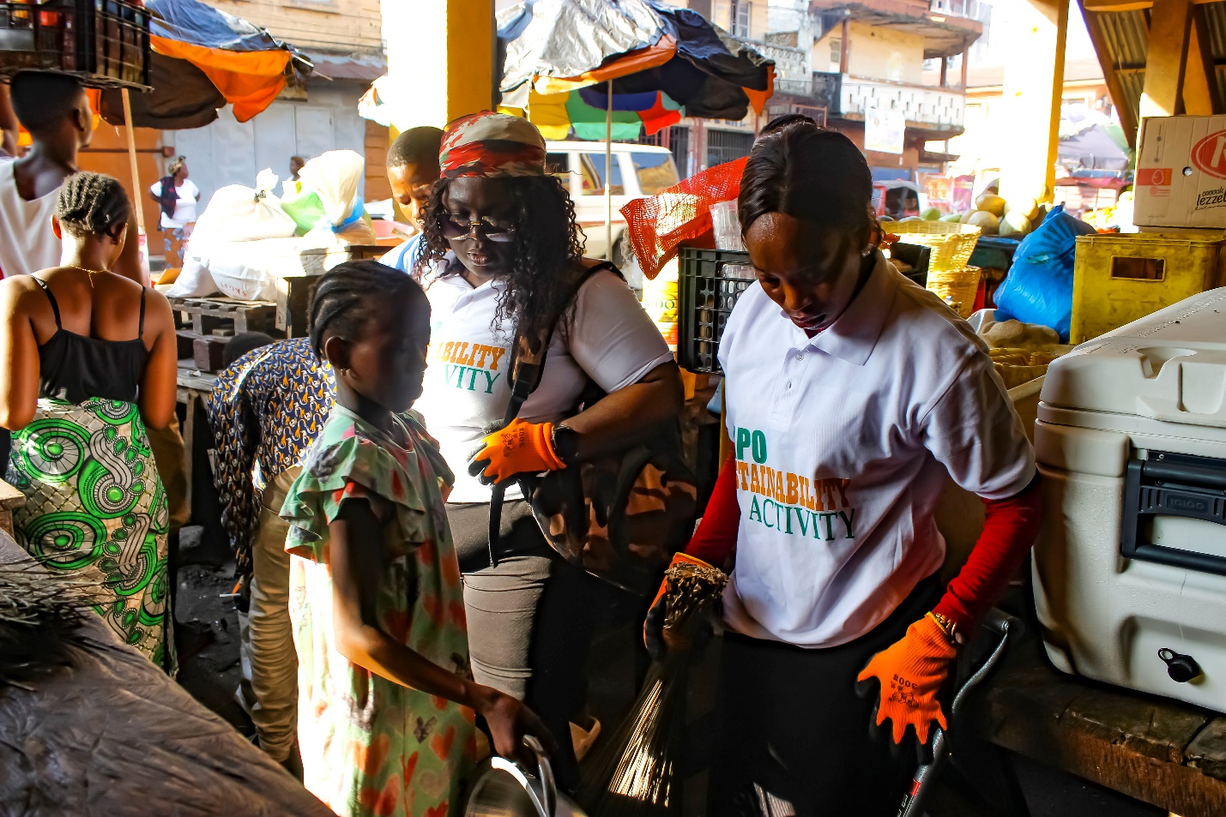
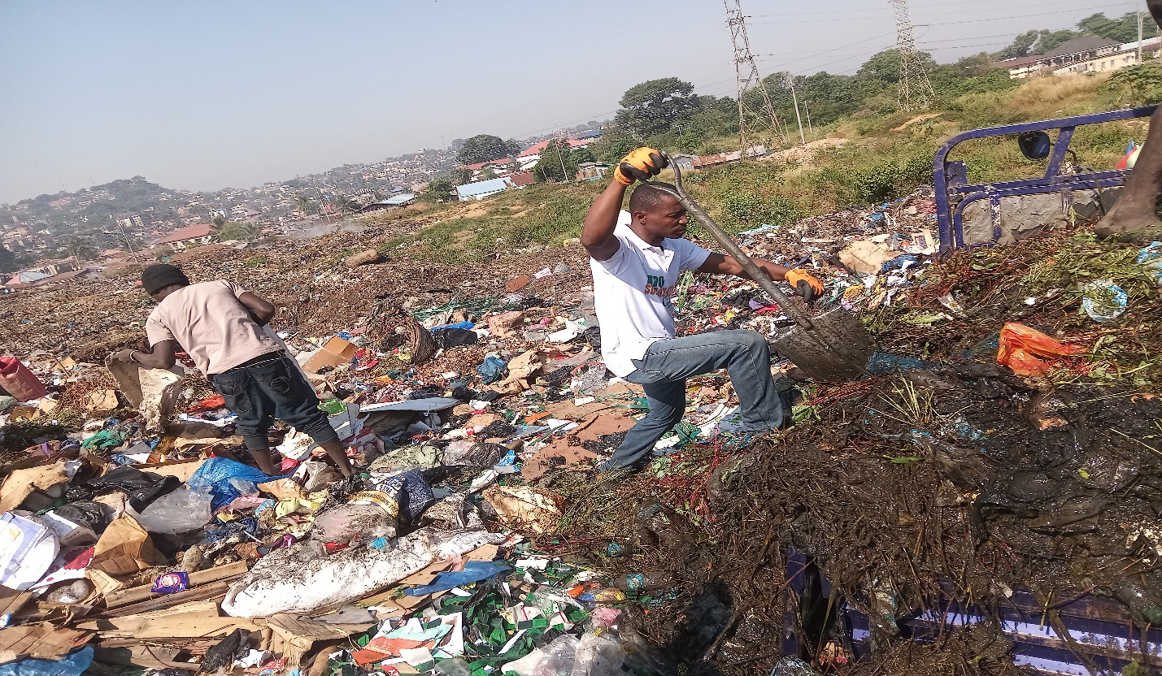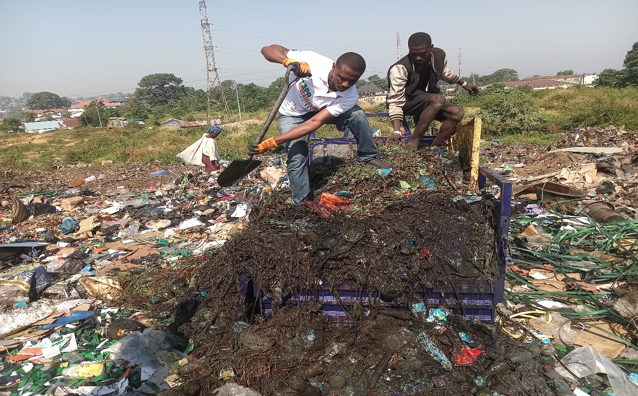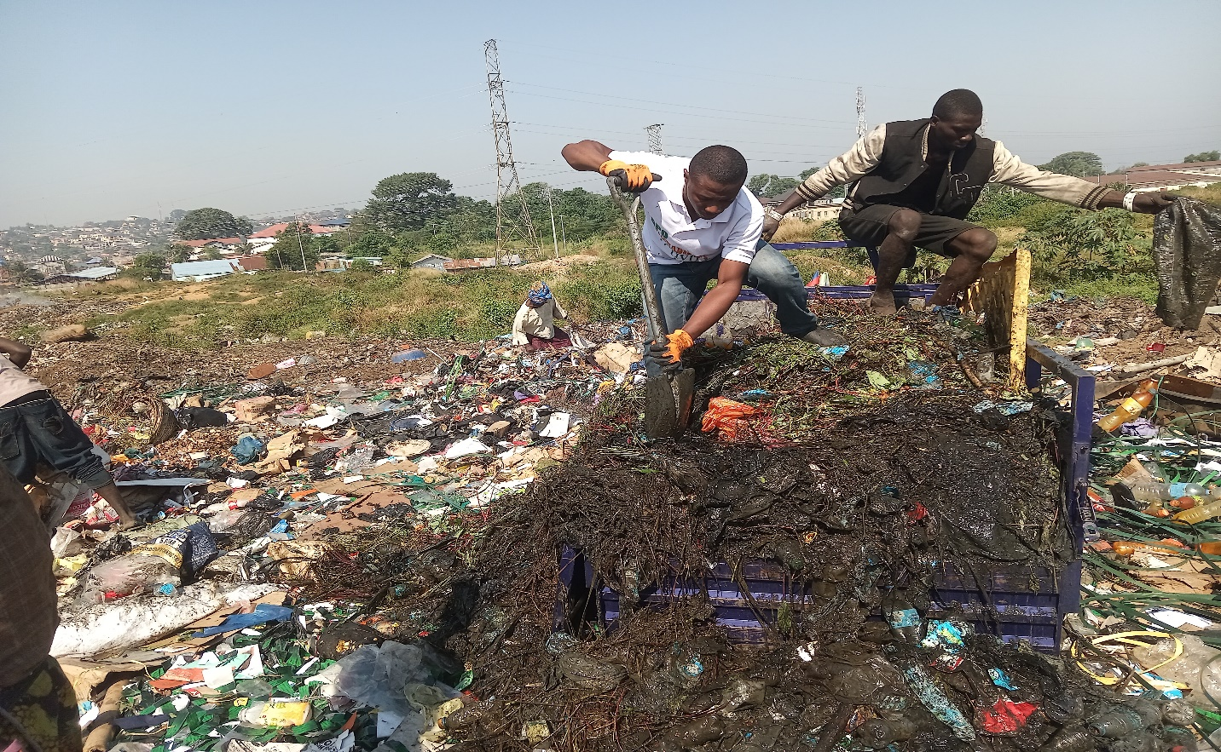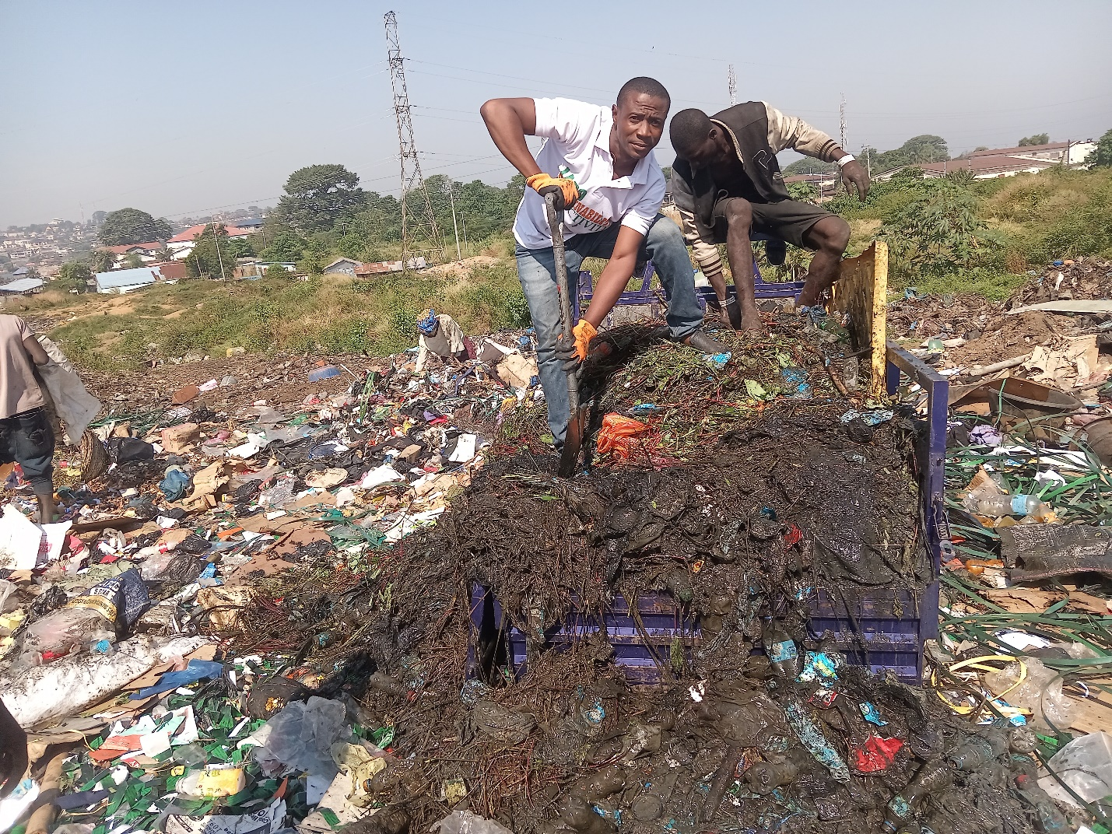

- People (Training and Social Events):
  - Clients Training:
The Sustainability Unit trained clients across all four quarters on topics such as health awareness, sanitation, gender-based violence, teenage pregnancy, and financial management.
Quantitative Summary:
Quarter | Clients Trained | Topics | Branches
First | 2,004 | Teenage Pregnancy and financial Management | Waterloo 1,Waterloo 2,Check point, Maymie, Allen Town, Rokupa, Rotifunk, Godrich, Freetown 1, Freetown 2, Lumley, Portloko , Makeni 1, Makeni 2
Second | 866 | Sanitation and gender base violence | Waterloo 2, Allen Town, Rokupa, Rotifunk, Godrich, Freetown 1, Freetown 2, Lumley
Third | 4,138 | Health awareness | Freetown 1, Freetown 2, Freetown 3, Brookfields, Lumley, Goderich, Allentown, Rokupa, Kissy, Mayemi, Waterloo1, Waterloo2, Checkpoint
Fourth | 4,765 | Health Awareness | Rotifuk, Lungai, Fenton, Bo Bank, Tinkonko, Shelmingo, Kenema1, Kenema 2, Tongoh, Mile 91, Kambia, Barracks, Portloko, Makeni 1, Makeni 2, Clock tower
Total | 11,773 |  | 29
Outcomes:
- Improved community knowledge on health and gender issues.
- Enhanced financial literacy for better income management.
- Promotion of peer-to-peer learning through trained group leaders.

  - Health Campaigns
Free Blood Pressure Testing:
LAPO provided free blood pressure testing for women covering ten (10) of her branches across Sierra Leone. Below are the details
S/n | Branch | No. of Beneficiaries
1 | Magburaka | 570
2 | Portloko | 445
3 | Makeni 1 | 350
4 | Rokupa | 168
5 | Allen Town | 350
6 | Mayemi | 50
7 | Waterloo 2 | 300
8 | Waterloo 1 | 400
9 | Goderich | 120
10 | Brookfield | 45
 | Total | 2,798
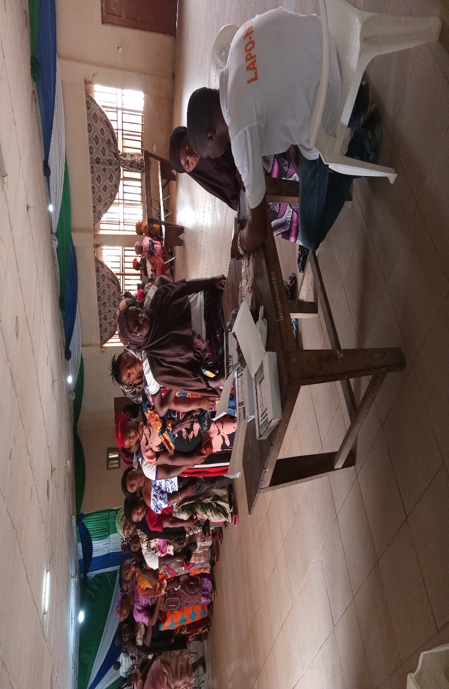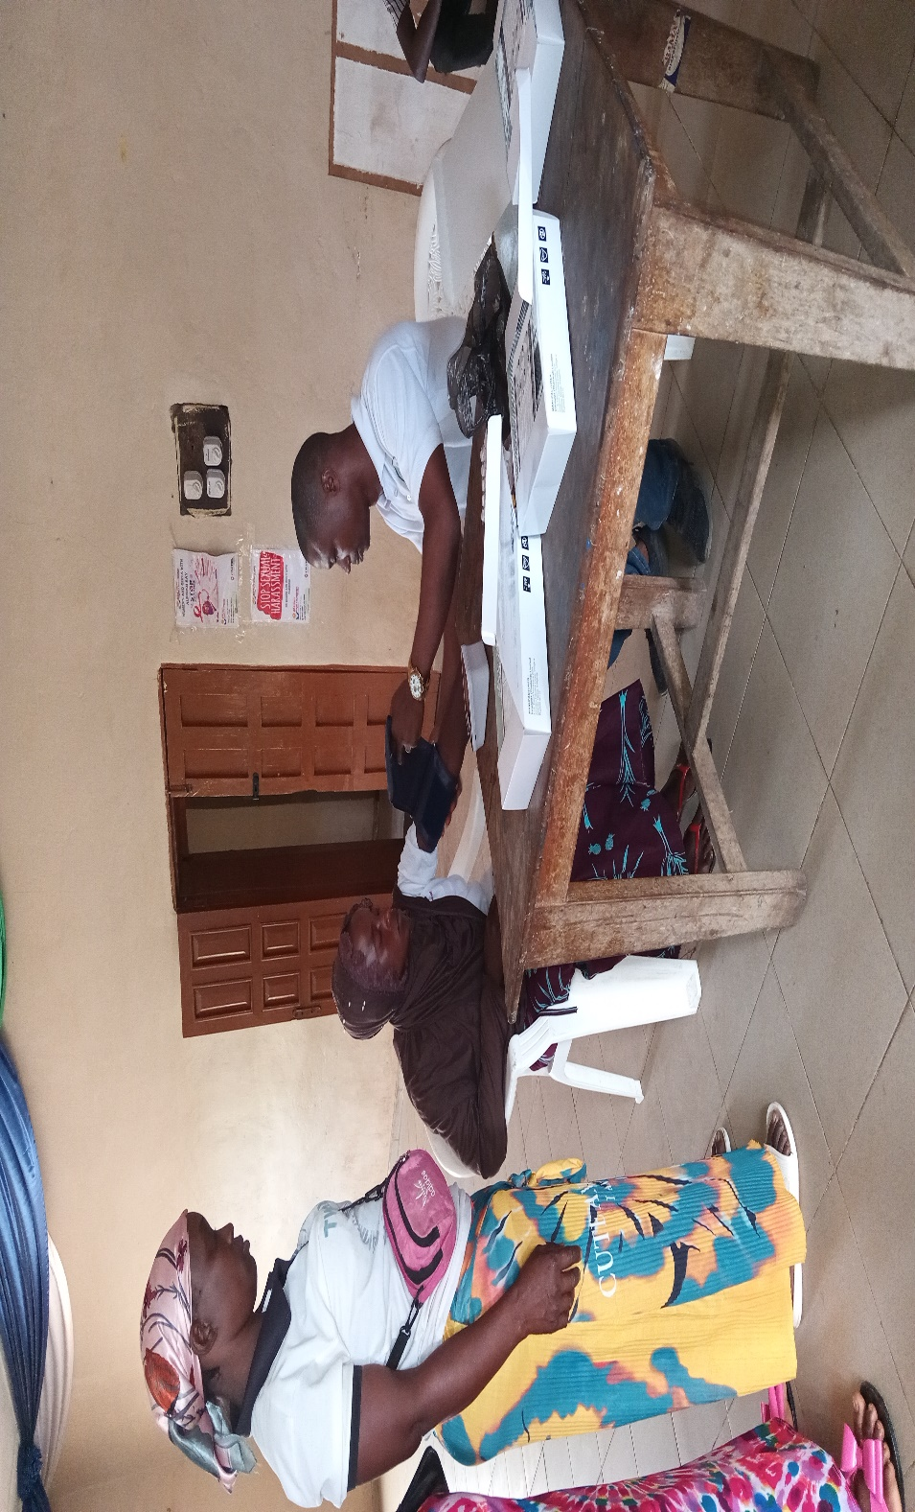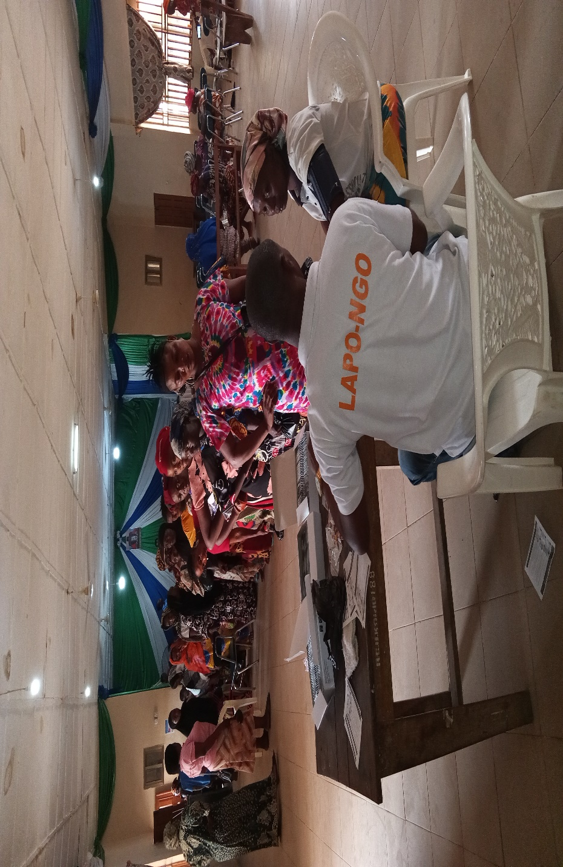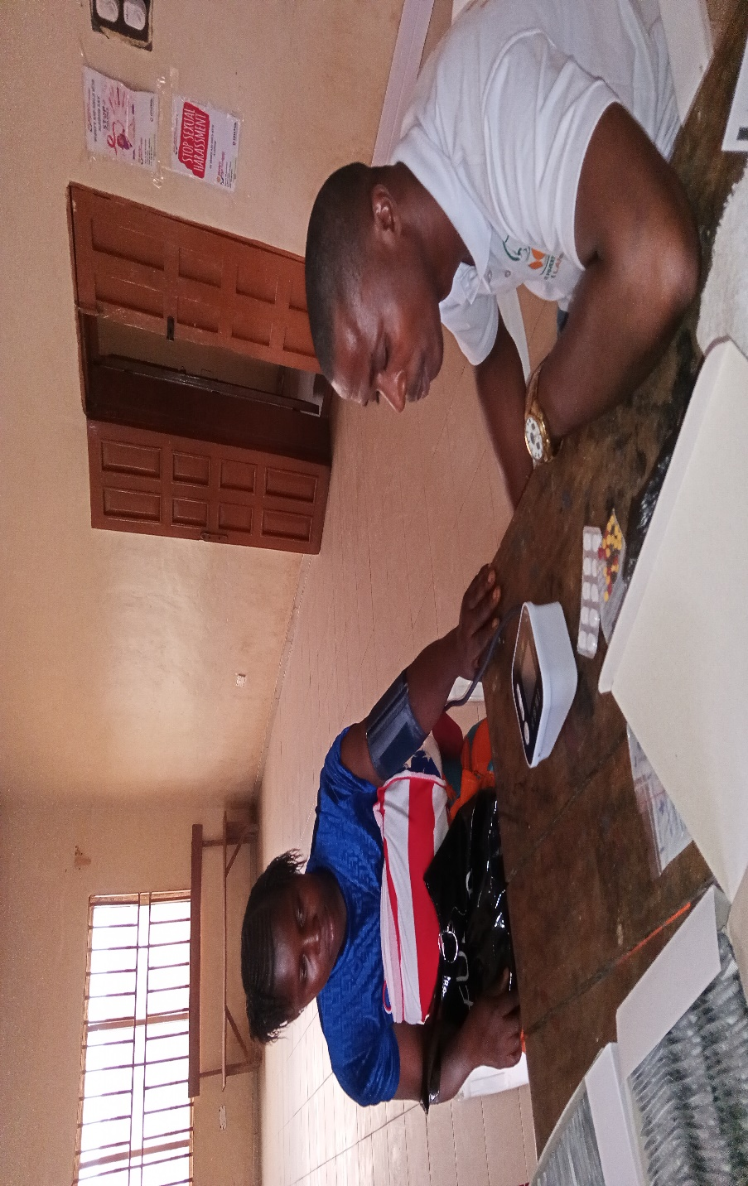

Female Health Care and Menstrual Hygiene:
LAPO provided health care and menstrual hygiene trainings to female students in ten (10) schools across Sierra Leone. This also involved the distribution of menstrual pad to the students. Below are the details
S/n | School | No. of Students Reached
1 | Freetown Secondary School for Girls | 125
2 | Dr. S. M Broderick Secondary School | 137
3 | Dr. June Municipal Secondary School | 154
4 | Commence John Memorial Secondary School | 250
5 | Methodist Girls High School | 230
6 | UMC Secondary School | 400
7 | Government Model Secondary School | 340
8 | Government Rokel Secondary School | 170
9 | Government Secondary Technical School | 87
10 | Government Secondary School | 98
 | Total | 1,991
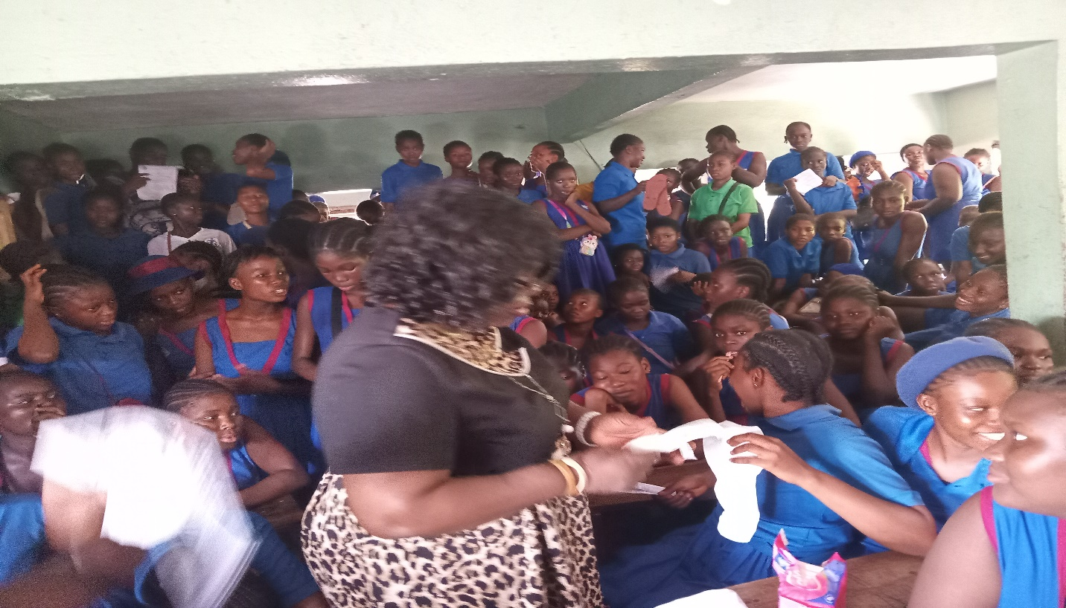
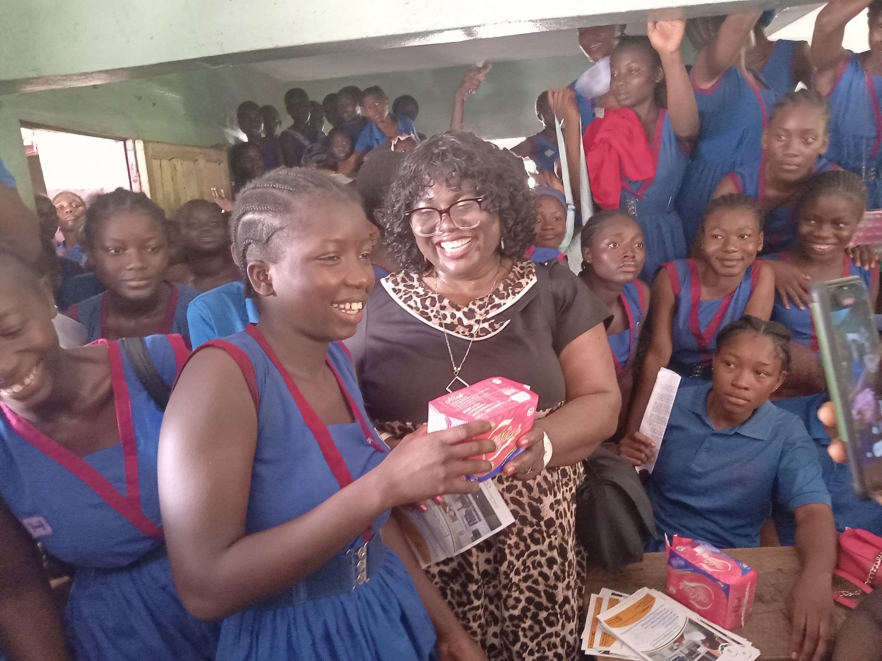
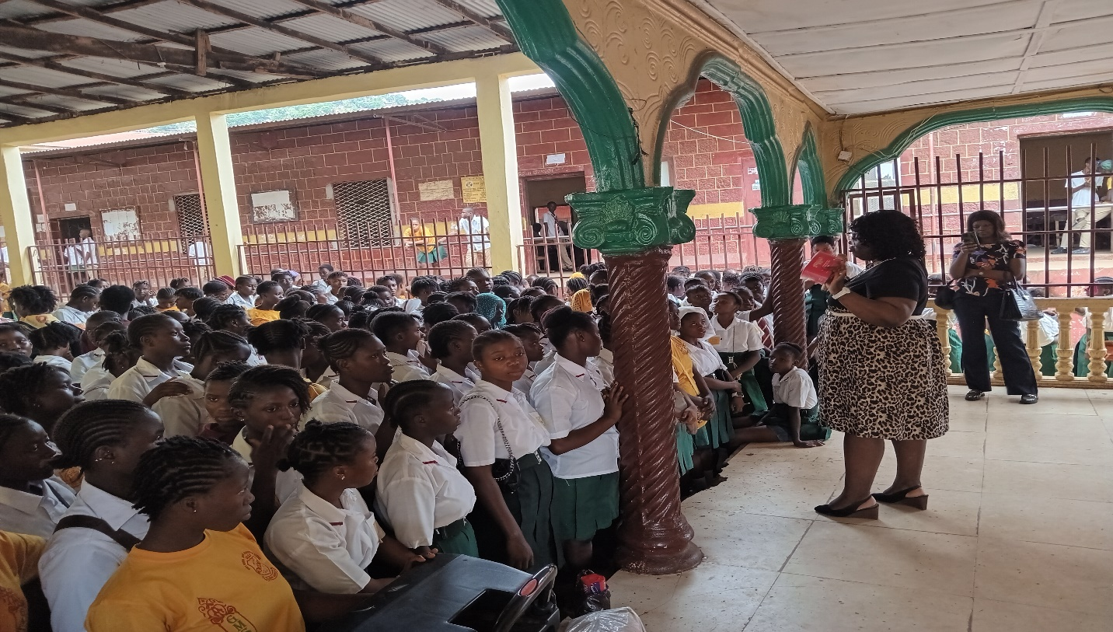

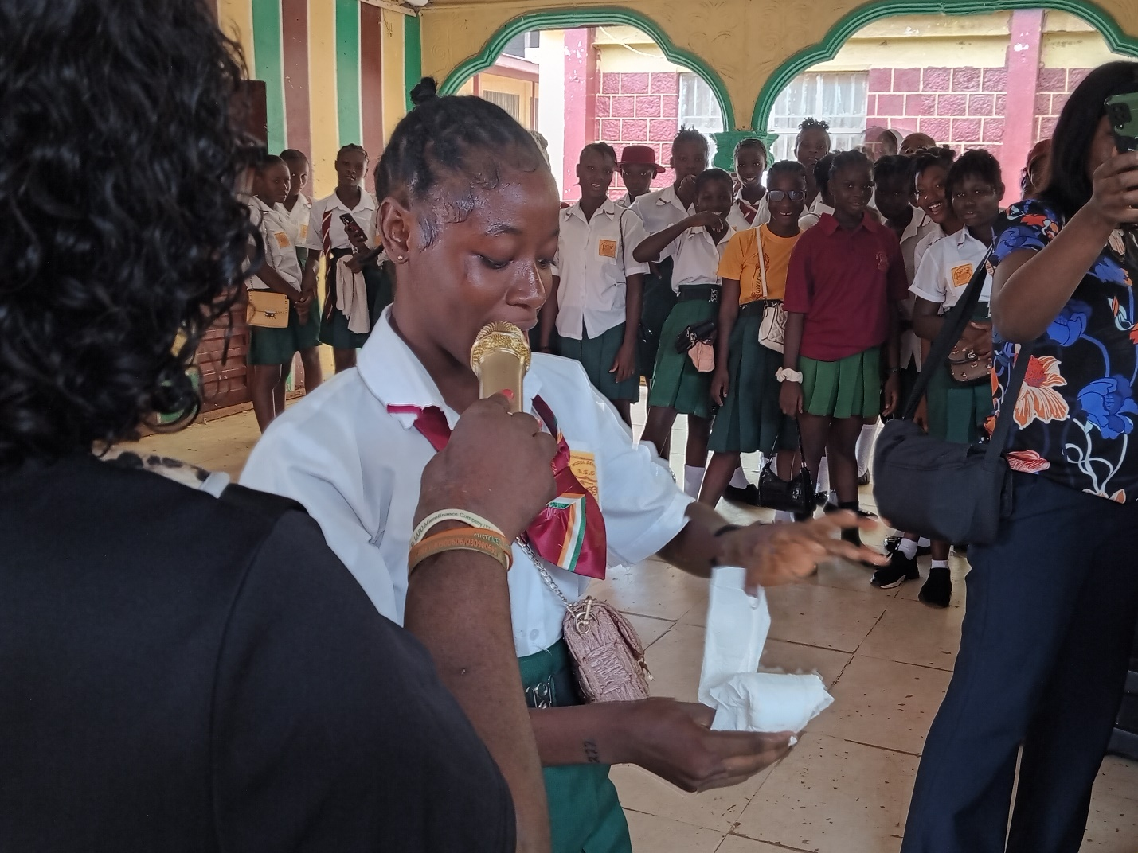
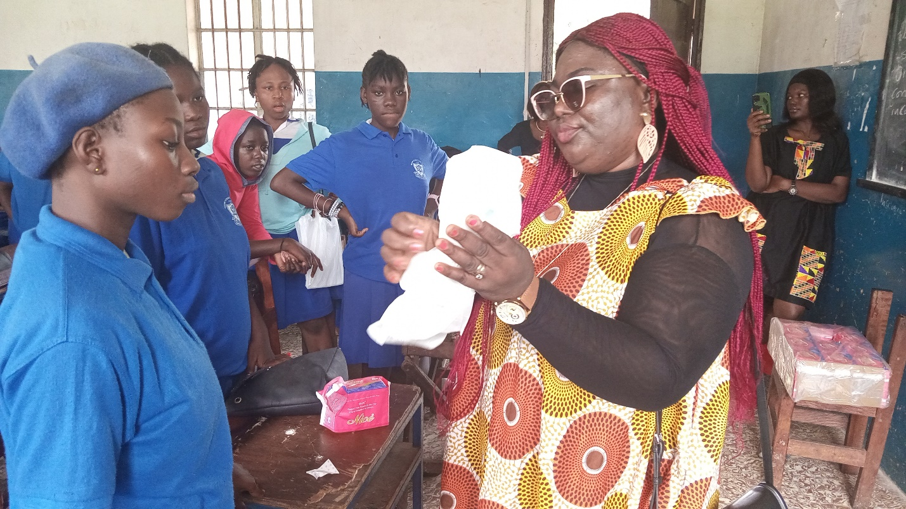
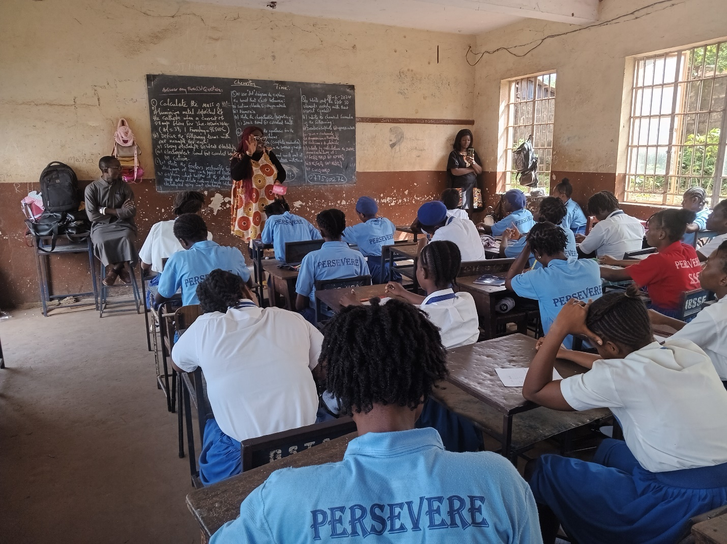

First Aid Kit Training:
LAPO distributed first aid kit across her 38 branches to create health care awareness amongst the staff of her 38 branches. See details below;
Scope | Description
Branches | 38 branches + Head Office
Staff Trained | All designated first aid personnel
Impact:
- Increased access to basic health services.
- Reduced stigma around menstrual health.
- Enhanced workplace safety through first aid preparedness.

  - Social Events
International Women’s Day:
LAPO played key roles in the celebration of women across Sierra Leone as a Nation on the International Women’s day. Below are the details
S/n | Group | No. of Participants
1 | Women with Disability | 60
2 | Women who are HIV+ | 30
3 | Commercial Sex Workers | 40
4 | Representatives of Women’s Groups | 20
 | Total | 150
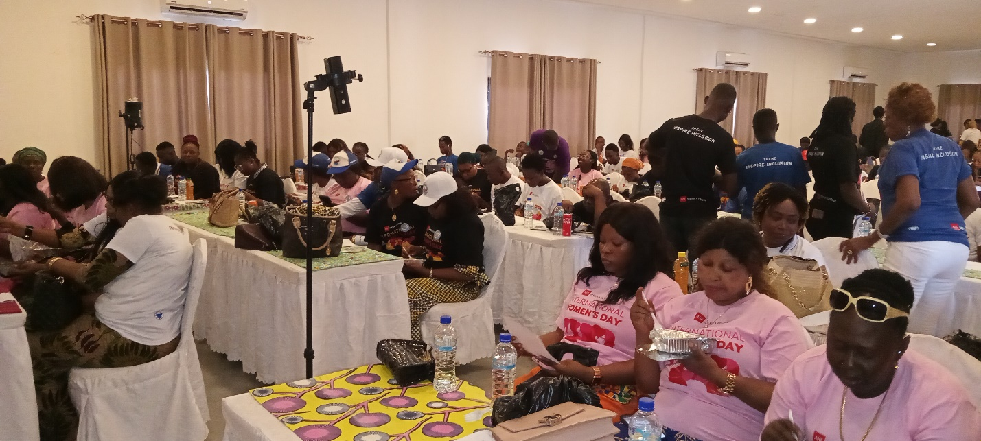
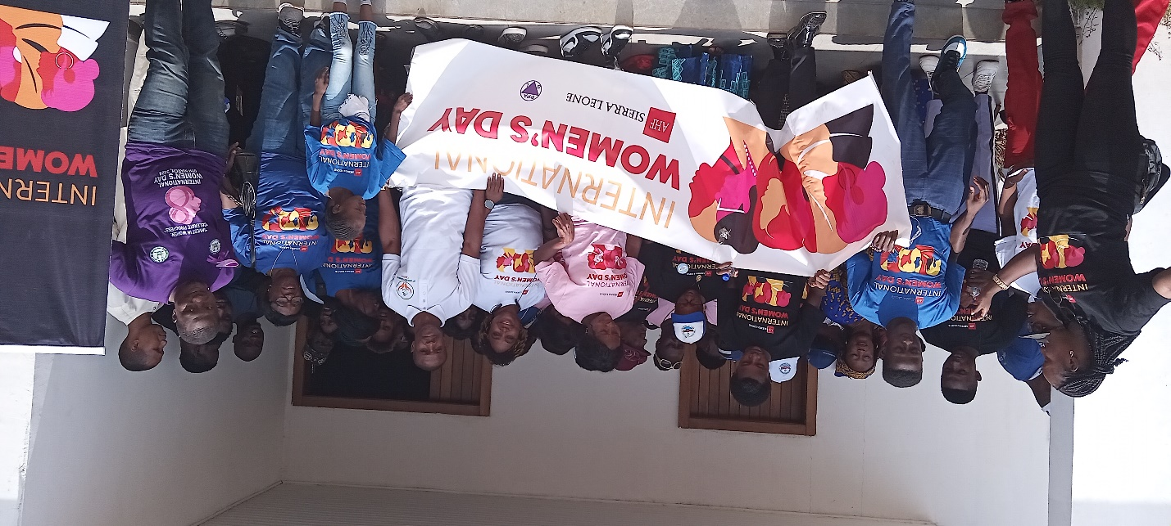
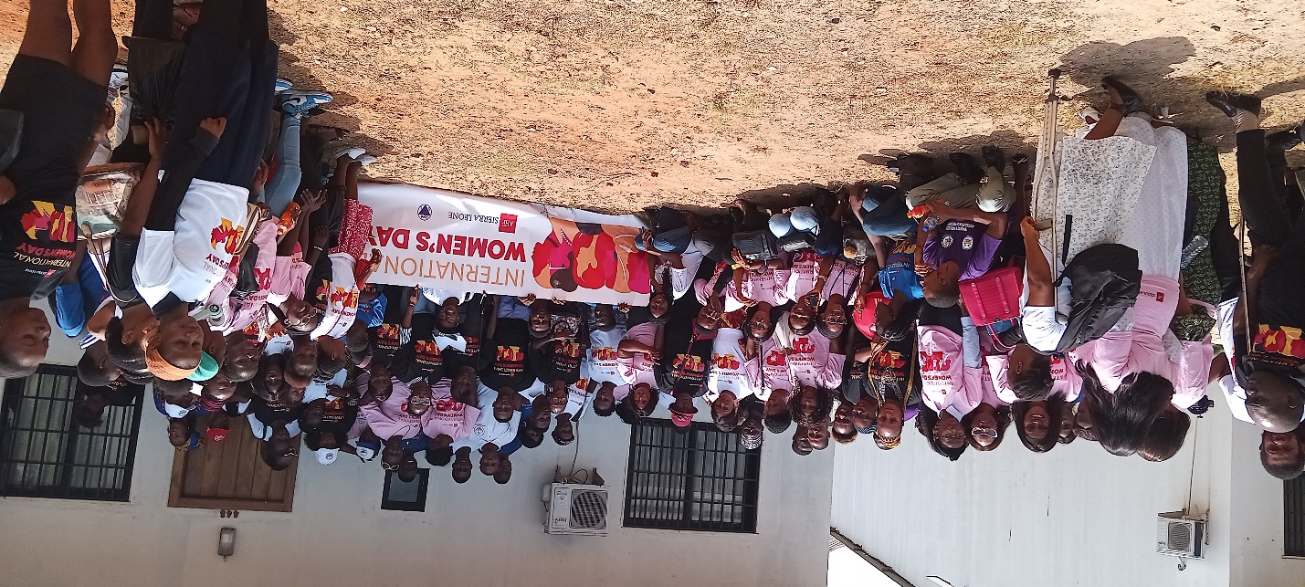
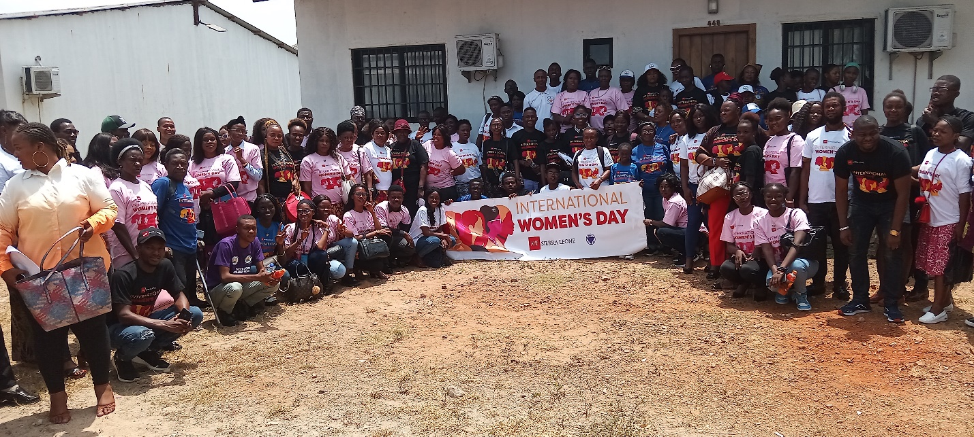

World Children’s Day:
LAPO also played a key role in the celebration of Children in about ten (10) Schools across Sierra Leone as a Nation on the World’s Children day. Below are the details
S/n | School | No. of Children Benefited
1 | Jawille Lewis Preparatory School | 230
2 | Gethsemane Preparatory School | 133
3 | Flaming Preparatory School | 300
4 | Baana Preparatory School | 356
5 | Donet Preparatory School | 287
6 | St. Anthony Primary School (Boys) | 357
7 | Dr. June Primary School | 345
8 | Christ Church Primary School | 168
9 | Buxton Primary School | 230
10 | Four Square Preparatory School | 119
 | Total | 2,525

Impact:
- Promoted gender equity and inclusion.
- Empowered vulnerable women with knowledge and support.
- Encouraged educational values among children.
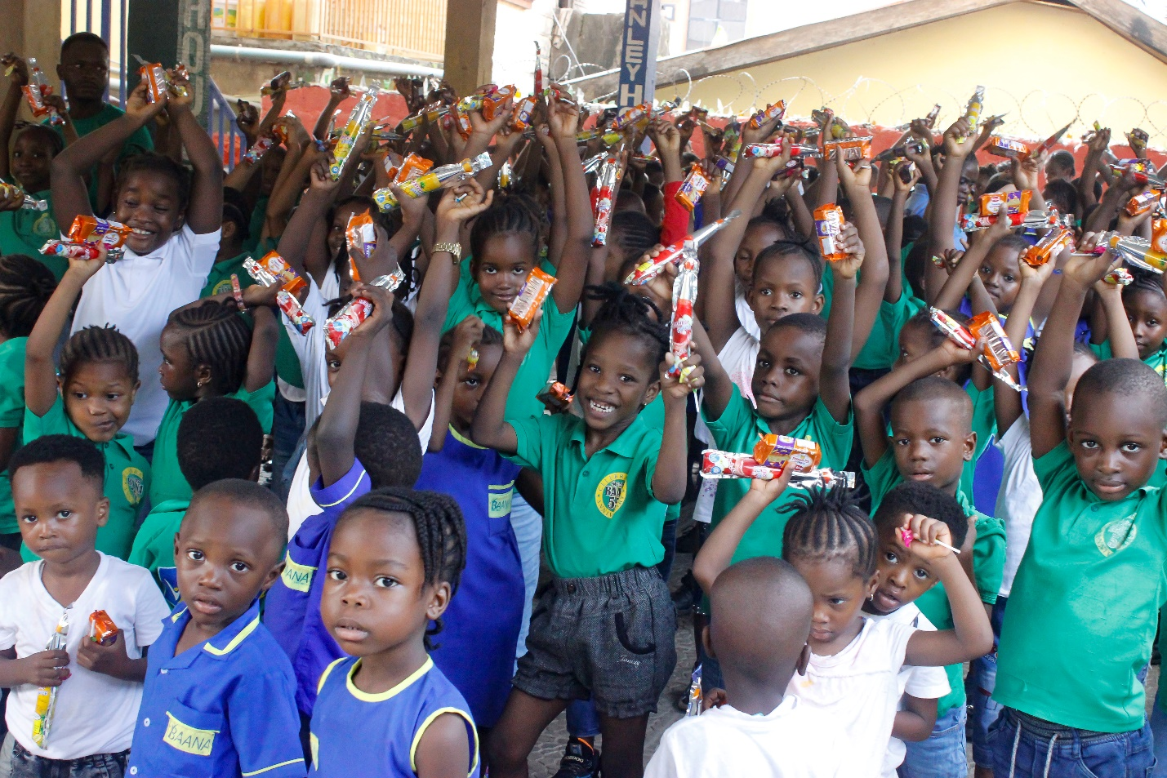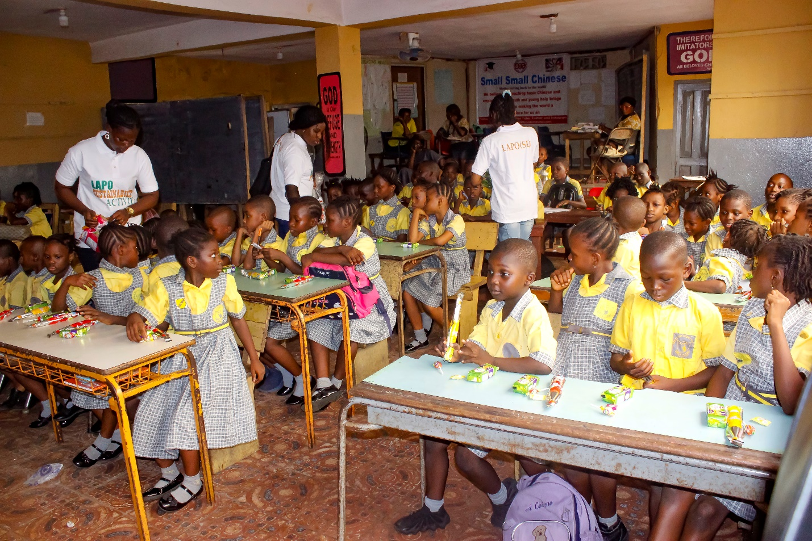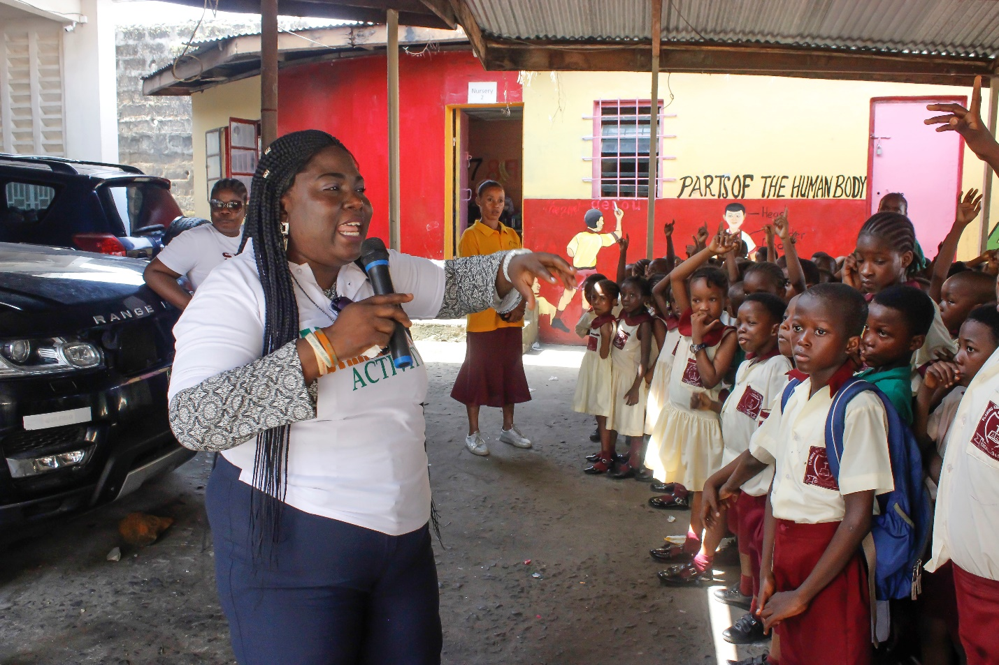
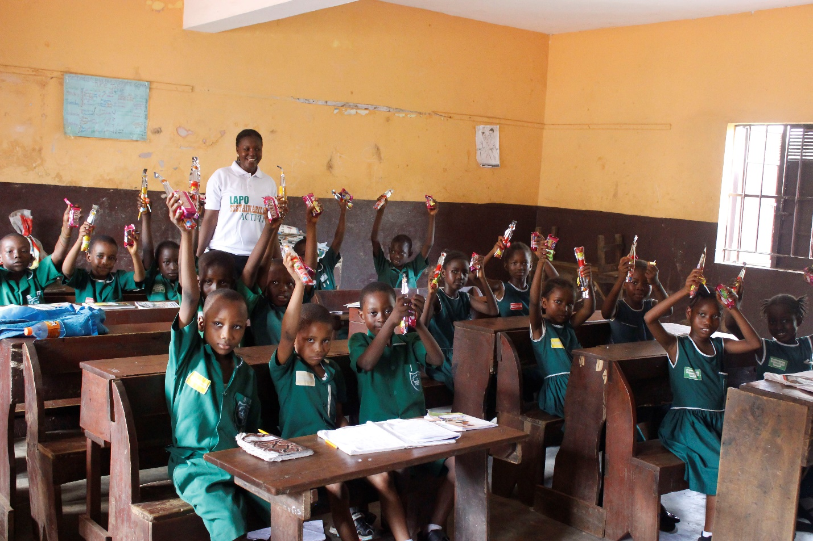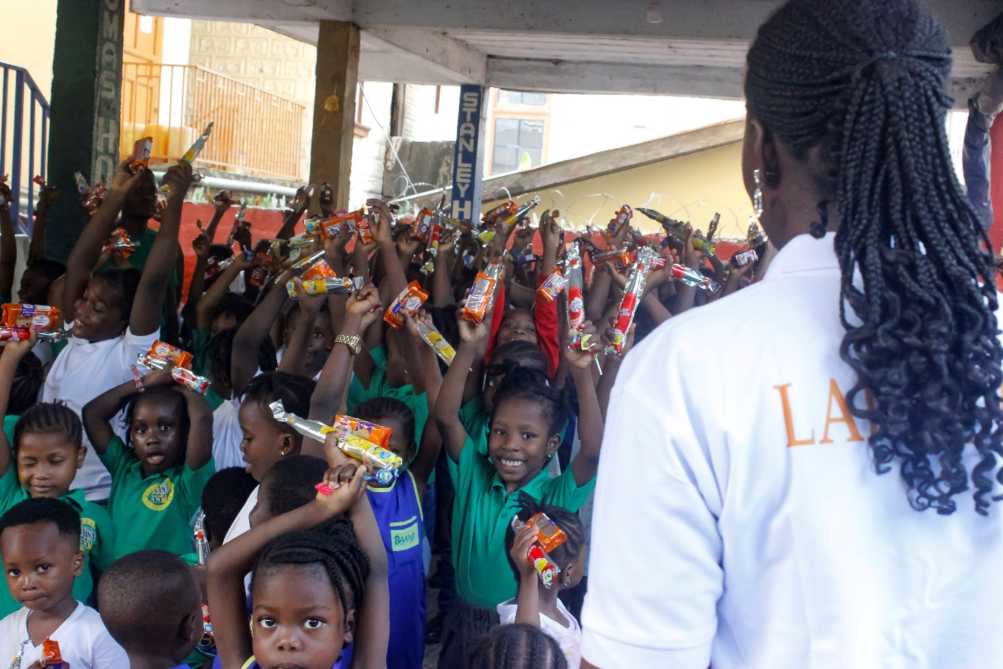
Conclusion:
The year 2024 marked significant progress in LAPO Microfinance Company (SL) Ltd.'s sustainability initiatives. Through targeted environmental and social interventions, the organization has demonstrated its commitment to inclusive development and responsible business practices. Continued efforts and partnerships will further strengthen these achievements in the coming years.

